Year 1 and 2 Ideas for Holy Week
Make a palm leaf to wave as you walk around your house or garden shouting ‘Hosanna!’ as loud as you can!  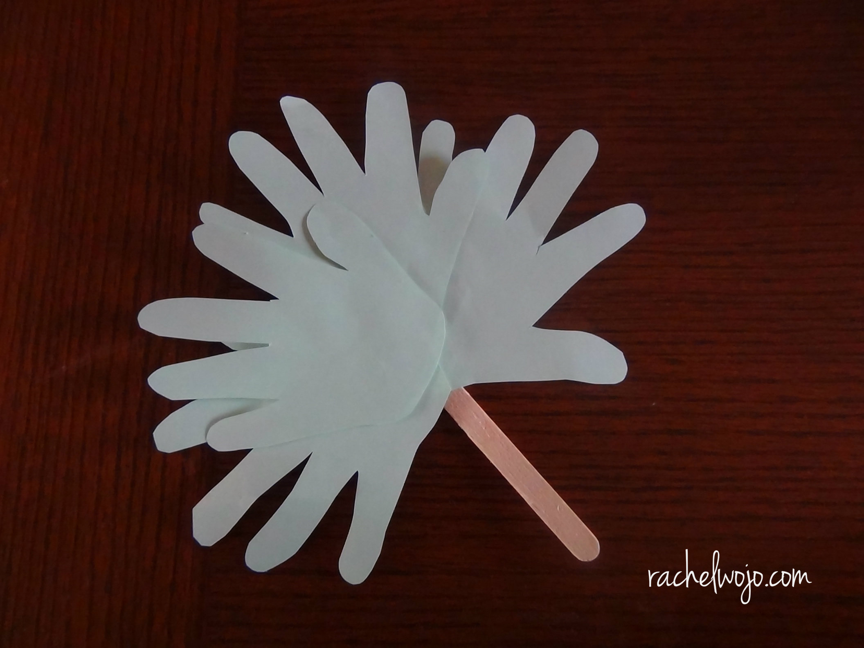 | Make your own Easter garden to show the Easter story using art materials and things you can find in your garden. See Mrs Mann’s Makes guide on our Home Learning Page for ideas.  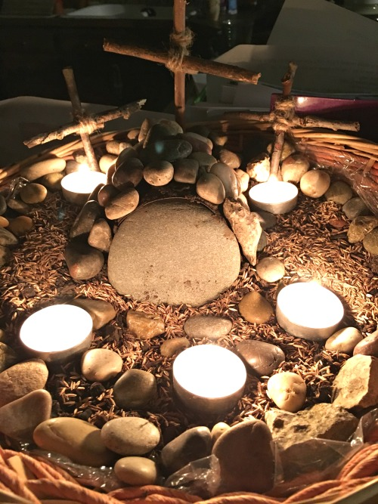 | Use juice and biscuits to act out the Last Supper with your teddies or toys. Remember to tell them “This is my body” and “This is my blood”.  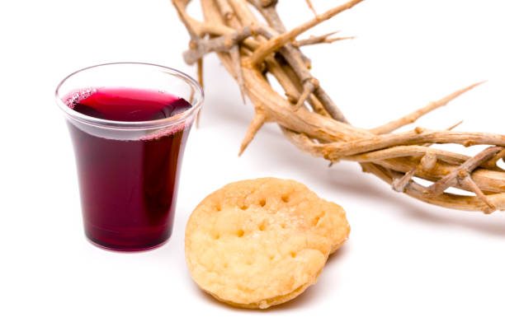
Make an Easter Card for someone in your family!  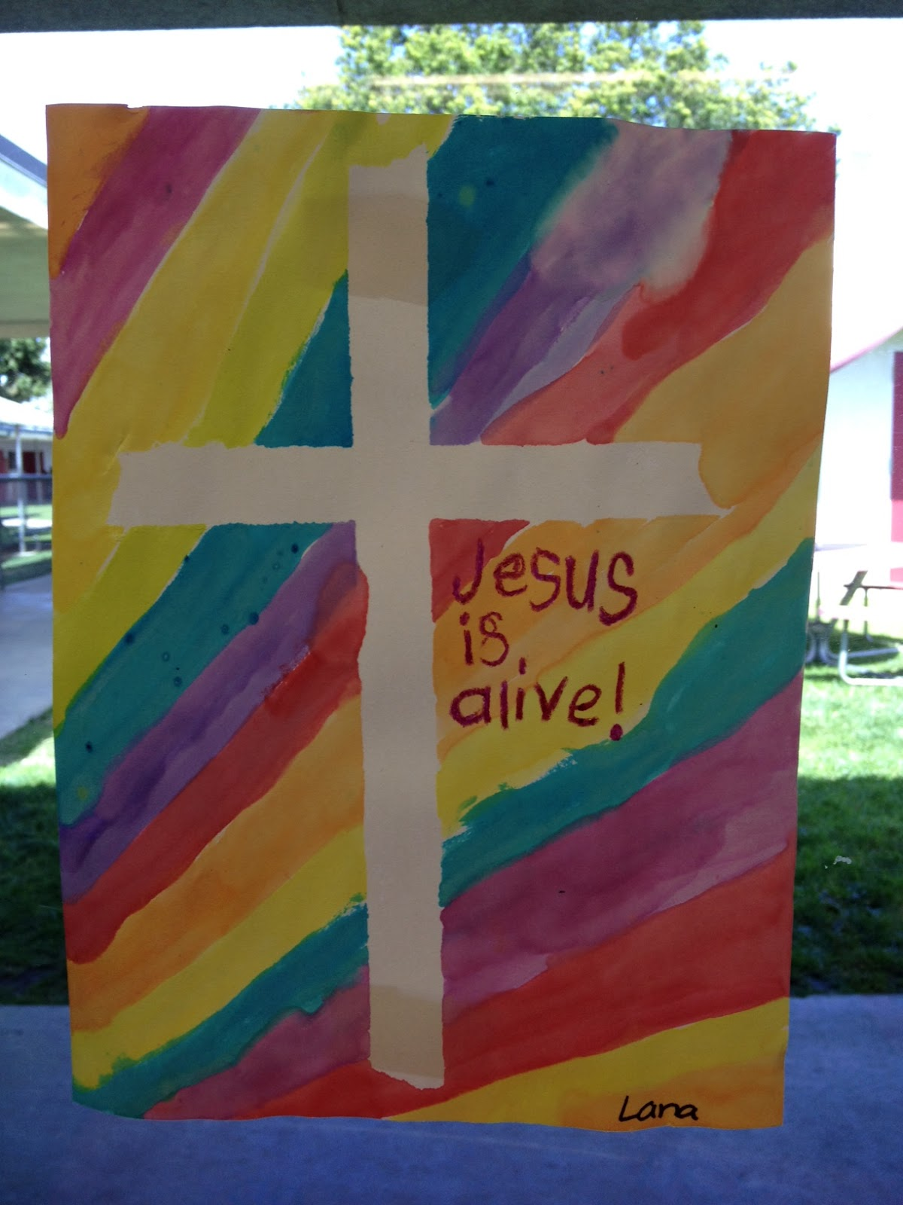 | Decorate a hard boiled egg and talk about the real meaning of eggs at Easter (new life).  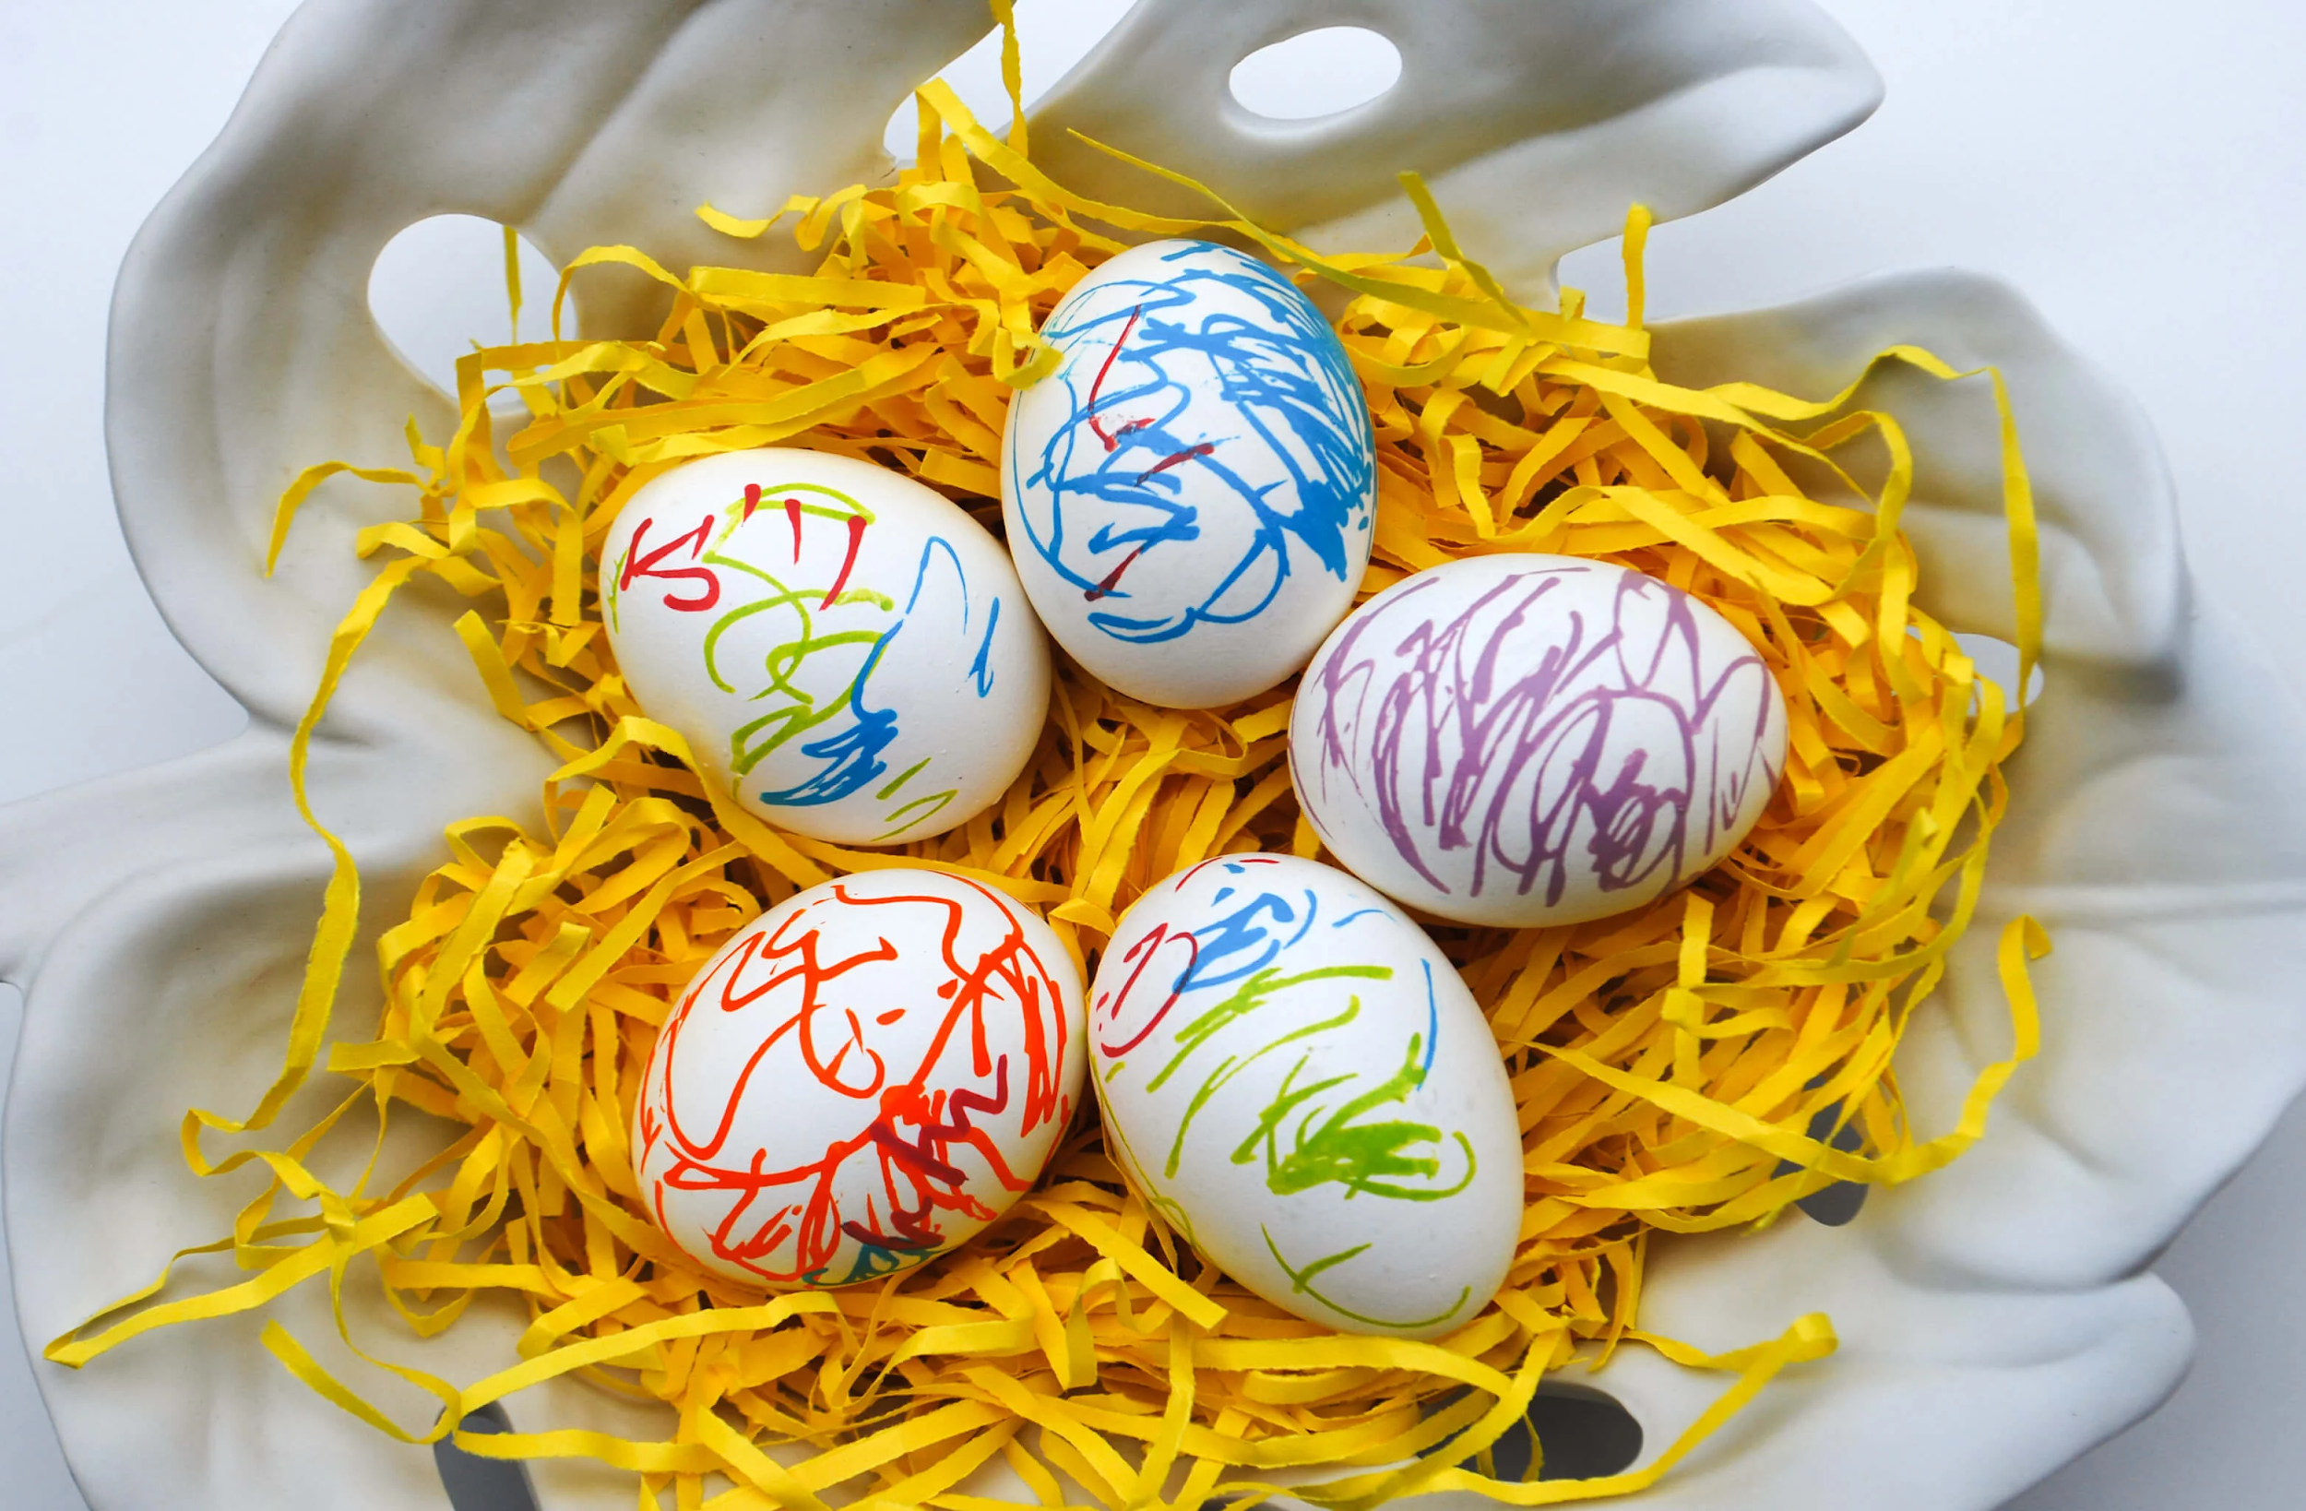 | Read the Easter story in a children’s Bible if you have one. Alternatively, you can watch an animation of the story here https://www.youtube.com/watch?v=0PSgoPdKQFQ  