 | Monday | Tuesday | Wednesday | Thursday
 | Palm Sunday | The Last Supper | Garden of Gethsemane | Good Friday
 | Read about Palm Story using Easter Story Powerpoint or Children’s Bible . | Read about The Last Supper using Easter Story Powerpoint or Children’s Bible . | Read about The Garden of Gethsemane using Easter Story Powerpoint or Children’s Bible . | Read about The Crucifixion using Easter Story Powerpoint or Children’s Bible .
Craft Activity  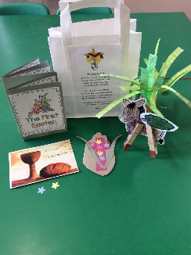 | Make a Palm Leaf  You could colour in a palm leaf shape and snip lines in with scissors, create a palm leaf using weaving skills or roll, fold and snip paper.  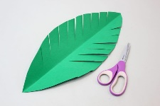  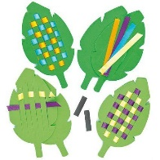  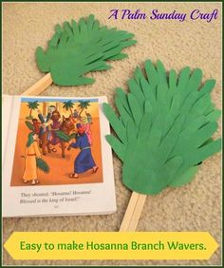  Clothespin Donkey Craft  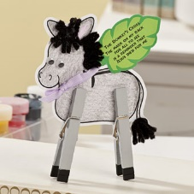 | Last Supper Role-Play  Re-create The Last Supper with your family, teddies or dolls. Lay a table with a cloth, place some bead and put it on a plate, fill a jug with blackcurrant juice and sit your family, teddies or dolls around the table. Role-Play Jesus breaking the bread and blessing it using the words from the story, then bless the ‘blackcurrant wine’ and share it around the table. | Make an Easter Prayer Card.  Fold a piece of card in half and draw around your hand, fingers together right on the edge of the fold. Cut it out, remembering not to cut the across the fold.  Cut out a cross shape and stick it onto the front of your card, then decorate it with anything you like. Cut out 2 strips of paper for palm leaves and stick either side of cross.  Write the prayer inside.  I hold these hands  Into a prayer  To thank the Lord  For love and care  Fold your hands  Right next to me  And he will love  Us both you’ll see. | Make an Easter garden.  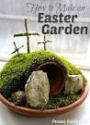  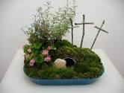
My First Easter Story Mini-Book | Start My First Easter Story Mini-Book.  Fold a large piece of paper in half lengthways, then fold widthways in half, the half again to create a zig zag book. Colour title page and pages 2 and 3, then stick into book. You could add a sentence about the picture. | Colour page 4 of The Easter Story and add to book. | Colour pages 5 and 6 of The Easter Story and add to book. | Colour pages 6 and 7 of The Easter Story and add to book. Your book is now finished and can be placed on your Journey of Easter.
Journey of Easter | Get a large piece of paper or cardboard and draw a winding road from top to bottom. Draw and colour people make buildings from cereal boxes, lego etc to create Palm Sunday scene at beginning of the road. This will be added to daily throughout Holy Week. Place your Clothespin donkey on the road. | Draw Jesus and his disciples and create the Last Supper scene for your Journey of Easter. Draw a picture of the chalice and bread and write ‘Remember Me’. Place on The Last Supper table. | Make flowers and trees to create the garden of Gethsemane on your Journey of Easter. Place your prayer card in the garden you have created. | Make a cross out of sticks and a hill out of playdough or paper to place at the end of the road on your Journey of Easter. You could also make a tomb out of lego, or playdough. You could put your Easter Garden her as well. Light a candle and ask a grown up to read the Easter prayer below.
The First Easter
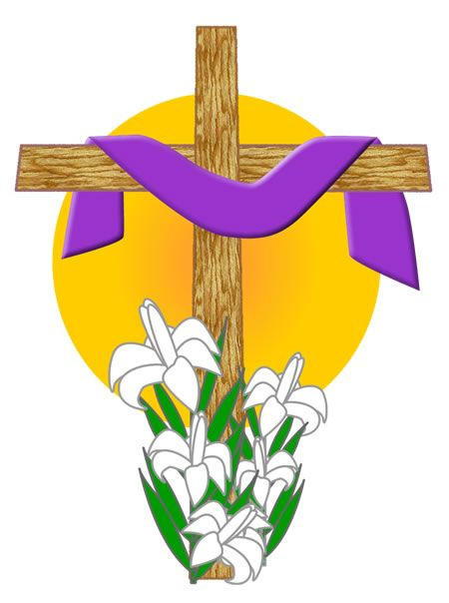
God made you and God made me,
He made the world for us to see.
God loves you and long ago,
He sent his Son to tell us so.
Jesus showed us many things,
To love and share and dance and sing.
To learn and pray, to help and care,
He promised he'd always be there.
He died but then came back to life,
Let's celebrate for he's alive!
Amen.

