Year 5 and 6 Spanish w/c 18th May 2020
Activity 1:
Can you remember numbers 1-50? Play these games to practise https://rockalingua.com/games/numbers

Activity 2:
Can you say the shirt numbers of the football players below?
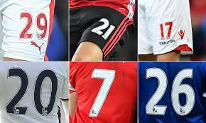

Activity 3:
What are the answers to these sums in Spanish?
4 x 4
12 x 2
17 + 6
25 + 17
5x 6

