

**Earth Day Scavenger Hunt**

Find 3 different kinds of leaves and make rubbings with a crayon or take a photograph.

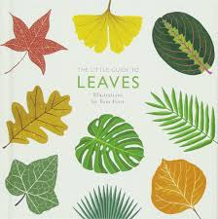

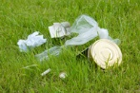

Pick up some litter to recycle or throw away.

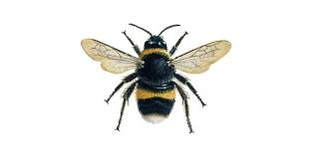

Find a bee or insect which spreads pollen.

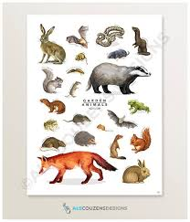

Sit quietly and look and listen for 3 different types of animals. Take photographs and see if you know their names.

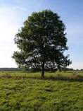

Find a tree which is taller than your house.



*We would love to see some photographs of your scavenger hunt. Please share on Tapestry. Thank you.*