Read Write Inc. Phonics

At Ladymount Catholic Primary School

Children who read regularly or are read to regularly have the opportunity to open the doors to so many different worlds! More importantly, reading will give your child the tools to become independent life-long learners.
We can achieve this together through:
- Read Write Inc. Phonics, a program to help to your child read at school.
- Encouraging children to develop a love of books by reading to them daily, at home and at school.
- Giving children access to a wide range of books at school and at home.
At Ladymount Catholic Primary School we use Read Write Inc. Phonics (RWI) to give your child the best possible start with their literacy. Mr Mulhall is our Early Reading Lead, so if you have questions about RWI, contact Mr Mulhall. Please take the time to read the information as it will provide invaluable information as to how you can help and support your child in reading.

What is Read Write Inc?

Read Write Inc (RWI) is a phonics complete literacy programme which helps all children learn to read fluently and at speed so they can focus on developing their skills in comprehension, vocabulary and spelling. The programme is designed for children aged 4-7. However we will continue teaching RWI to children beyond the age of 7 if they still need support in their reading.
RWI was developed by Ruth Miskin and more information on this can be found at https://ruthmiskin.com/en/find-out-more/parents/.

How will RWI be taught?

In Reception, children will be introduced to the initial sounds in short sessions, all children will learn how to ‘read’ the sounds in words and how those sounds can be written down.

Reading
The children:
- learn 44 sounds and the corresponding letters/letter groups using simple picture prompts – see below
- learn to read words using Fred talk and sound blending
- read from a range of storybooks and non-fictions books matched to their phonic knowledge
- work well with partners
- develop comprehension skills in stories by answering 'Find It' and 'Prove It' discussion questions

Writing
The children:
- learn to write and form the letters/letter groups which represent the 44 sounds with the help of fun phrases
- learn to write words by using Fred Talk*
- learn to build sentences by practising sentences out loud before they write

Talking
The children work in pairs so that they:
- answer every question
- practise every activity with their partner
- take turns in talking and reading to each other
- develop ambitious vocabulary
Year one and Year two children follow the same format as Reception but will work on complex sounds and read books appropriate to their reading level. Daily sessions of RWI phonics last for one hour. Once children become fluent speedy readers they will move on to literacy in Year One and Active English in Year Two.

Five key principles underpin the teaching in all Read Write Inc. sessions:
Purpose – know the purpose of every activity and share it with the children, so they know the one thing they should be thinking about
Participation – ensure every child participates throughout the lesson. Partnership work is fundamental to learning
Praise – ensure children are praised for effort and learning, not ability
Pace – teach at an effective pace and devote every moment to teaching and learning
Passion – be passionate about teaching so children can be engaged emotionally.

Key Skills:
We use pure sounds (‘m’ not’ muh’,’s’ not ‘suh’, etc.) so that your child will be able to blend the sounds into words more easily.

*At school we use a puppet called Fred who is an expert on sounding out words! we call it, ‘Fred Talk’. E.g. m-o-p, c-a-t, m-a-n, sh-o-p, b-l-a-ck.
The following video is an example of blending sounds with Fred
Blending with Fred
Step 1:
Set 1 Sounds are taught in the following order together with rhymes to help children form the letters correctly and instantly recognise sounds ready for blending.
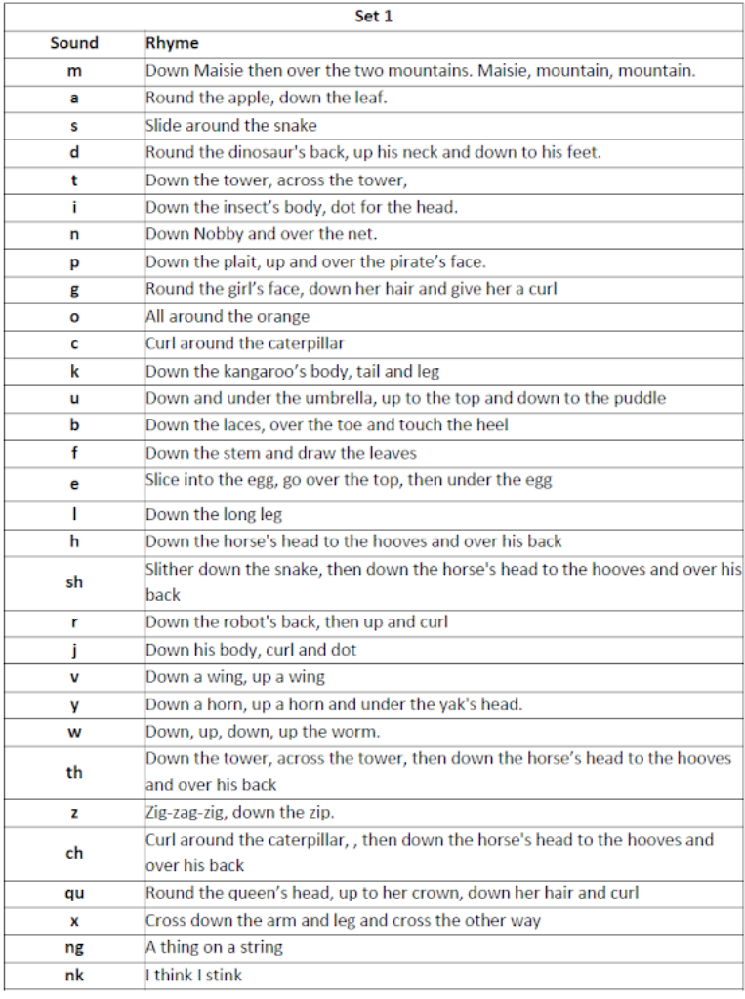

Click here for the top ten tips and help with how to pronounce sounds correctly.
Children will also use pictures for each sound to help recognise the sound and then form the shape of the sound.
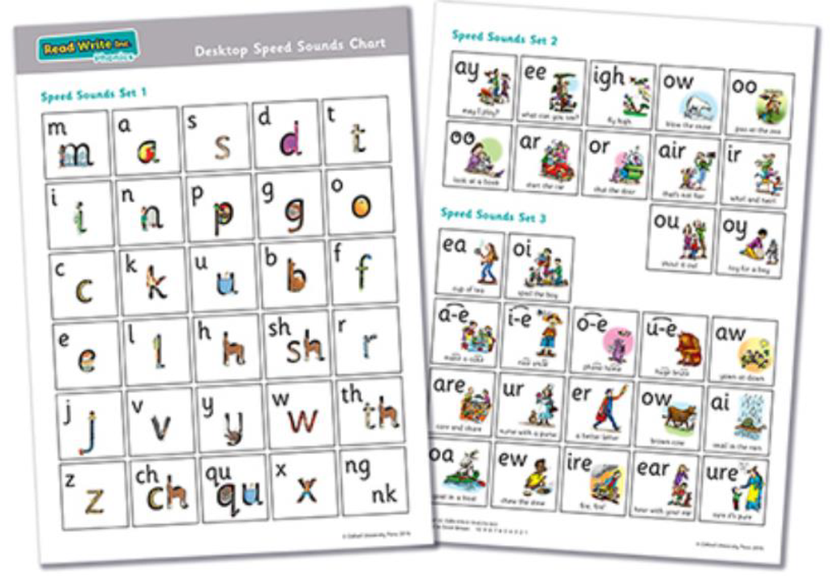

Step 2:
The children are then taught Set 2 Sounds - the long vowels. When they are very confident with all of set 1 and 2 they are taught Set 3 Sounds.
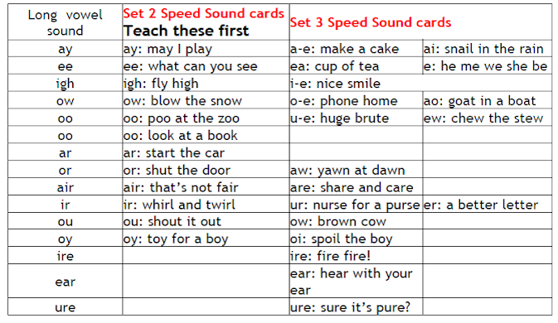

Nonsense words (Alien words)
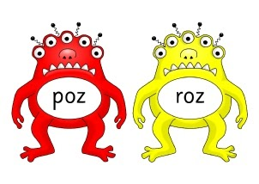

As well as learning to read and blend real words children will have plenty of opportunities to apply their sound recognition skills on reading ‘Nonsense words’. These words will also feature heavily in the Year One Phonics Screening check in the summer term.

The Year 1 Phonics Screening Check will take place in June.
This check simply identifies the children who need extra help so they are given support by their school to improve their reading skills. They will then be able to retake the check so that schools can track pupils until they are able to decode.

Step 3:
Children use sound-blending (Fred Talk) to read short books will bring these home once they have read and discussed the book in class. Children will then be challenged to use their developing phonic knowledge to write short sentences.

Within all the books children will have red and green words to learn to help them to become speedy readers. Red words are words that are not easily decodable and challenge words to extend children’s vocabulary. Green words are linked to the sounds they have been learning and are easily decodable.

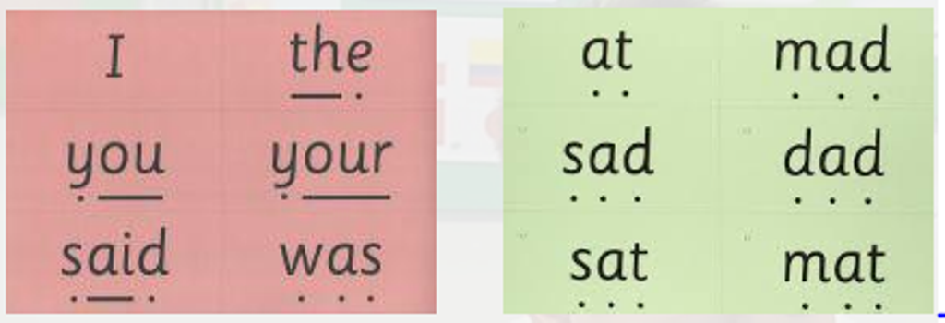

Dots and dashes represent the sound each letter makes.

To help at home:
Your child will start to bring books home when they are confident readers. Please help them to read and give lots of praise! If you have any other questions about RWI, please see your child's class teacher.

