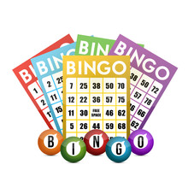
Prizes to Be Won!!!

Get your BINGO NIGHT tickets now on parent pay or pay cash at Preschool! Don’t miss out!
If you can’t make it buy a RAFFLE TICKETS £1 each! Cash at Preschool or on Parent Pay!
Revive Hairdresser – Cut & Style Voucher
Bien Hair & Beauty Voucher
Climbing at Activity for All Voucher
Inflation Nation Voucher
Meal for two at The Anchor
1 hour Reflexology Treatment
Pensby Kebab House Meal Vouchers X 2
Dine India Voucher
1 hour Golf Lesson
1 Term of Lesson at Helen O’Grady Drama School
Gift Bag from Mode Hair & Beauty
Sal’s Barbers Voucher
Aroma Coffee Shop Voucher
Brown Bear Coffee Shop Voucher
Pendant from Rojer’s Jeweller’s Irby
H Jones & Son’s Butchers Voucher
Irby Pet Store Voucher
10 pack of BREWDOG
Bottle of Bollinger Champagne
White Wine
Red Wine
Board Games
Cuddly Toys & more…

